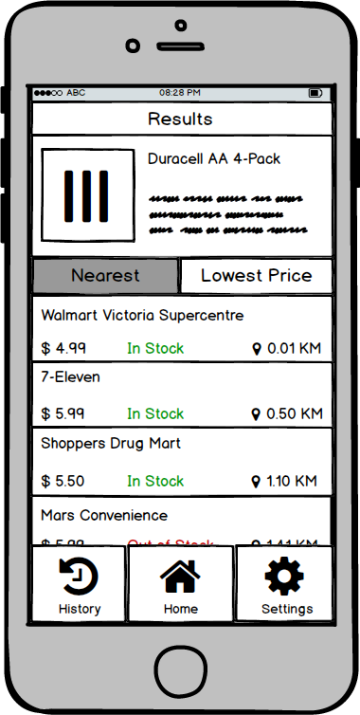

Nearest Lowest Price

**Walmart Victoria Supercentre**

$ 4 aq In Stock Ο Ο.Ο1 KM

**7-Eleven**

**$ 5.aq In Stock (9 050 KM Shoppers Drug Mart**

$5.50 In Stock 9 110 KM

**Mars Convenience**

**Settings**